St John Jubilee 2017
“Hometown Aloha”
May 26, 2017-6:00 P.M. to 12:00 A.M
May 27, 2017-9:00 A.M. to 5:00 P.M.
000000

Criteria
*No responsibility for loss or damage of any artwork or display in the show is assumed by the St John Jubilee Committee or the City of St. John. Liability Insurance is suggested.

*Exhibitor is responsible for setting up and taking down his/her own booth. Tables and/or chairs are not provided. All trash must be disposed of: trash cans are located at various locations along the square.

*EACH EXHIBITOR IS REQUIRED TO HAVE A KANSAS SALES TAX NUMBER.
Applications can be found at www.ksrevenue.org or by calling 1-785-368‐8222, option 5 then option 1.
Obtaining a Kansas Sales Tax number is free.

Application Procedures:
*Entry for St John Jubilee is on a first come first serve basis.

*Applications will be accepted until all spaces have been filled.

*The official application must be completed in full.

*Application must include a check for all applicable fees

*Booth space is only confirmed when payment is received.

Booth Information:
*Booth/Entry Fees are:
One-Day Prices: $40.00 per space without electricity
$45.00 per space with electricity.

Two-Day Prices: $45.00 per space without electricity.
$50.00 per space with electricity.

Informational/Non-profit Prices- $20.00 flat fee per space.

*Vendor Booth sizes are 10x10 feet. – Bring your own tables

*Some are located in full sun and subject to the elements so come prepared.

Parking:

*Vehicles must be removed from around the square after unloading. No exceptions.

**Please keep in mind, that getting last year’s booth space in not a guarantee, but a courtesy. Spaces are filled on a first come first serve basis according to when registrations are received. **

We welcome you to our show and look forward to another successful year. If you have any questions or concerns please feel free to contact us.

LaDona S Garcia, St John Jubilee Committee Email: sjcity@gbta.net Phone: (620) 549-3208
St. John Jubilee 2017
For Committee Use Only
Electricity Needed_______ Space #_______

Booth Registration

Contact
Name: __________________________________________________

Business
Name: ___________________________________________________

Address: _________________________________________________ Phone #: ____________________________

City: _______________________________________ State: ________________ Zip Code: ___________________

E-mail: _______________________________________________________________________________________

Description of Display: ____________________________________________________________________________________
____________________________________________________________________________________

Special Request: _______________________________________________________________________

SPACE DESIRED, PLEASE INDICATE NUMBER OF BOOTHS:

_____ One Day? Friday or Saturday Electricity? Yes-$45.00 or No-$40.00

_____ Two Days Electricity? Yes-$50.00 or No-$45.00

_____ Informational/Non-profit Friday or Saturday or Both $20.00

_____ Total Amount Sent (Make checks payable to City of St. John or pay online at www.stjohnks.com , Please Do Not Send Cash)

Send Fees and Registrations to:
City of St. John
PO Box 367
St. John, KS 67576

As an experienced crafter do you have any suggestions that would make our show better?
_____________________________________________________________________________________

I have read all the application information and agree to abide by the rules and regulations of the Jubilee. Failing to do so may result in my being asked to leave the show, without refund, and that I may not be eligible for future shows. I release The St John Jubilee Committee and the City of St John from any losses, claims, liability or theft that arises as a result of my entry in the show. I understand there are no refunds due to inclement weather. Your signature indicates acceptance of all conditions of this prospectus. APPLICATION FORMS WITHOUT A SIGNATURE WILL NOT BE ACCEPTED.

Signature: __________________________________________________________ Date: _____________
ELECTRICITY QUESTIONNAIRE
FOR BOOTH REGISTRATION

Name:

TRAILERS
- Check the style of plug your trailer requires?
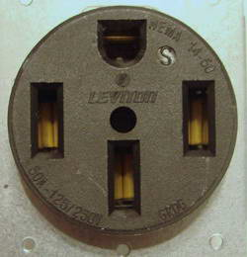
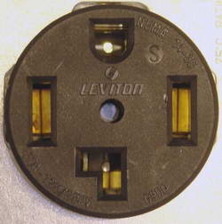
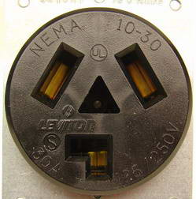
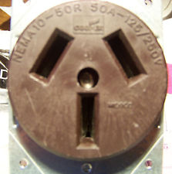

Other-(please describe)_________________________________
_________________________________________________
_________________________________________________

- Is your trailer equipped with a main disconnect? If so, what is the amperage? If not, what is your total amperage load? _____________

BOOTHS
- What is the number of plug in receptacles will you require?

- What type of equipment are you utilizing and how many?

- What is your maximum total watt of all your equipment? _______________

On booth rentals, the City uses 15 amp receptacles with a maximum of 120 volts.
The city will only provide extension cords to connect the booth to the receptacle.

Thank you for supporting the St. John Jubilee!!!!!

